**DontDie**

DontDie is a side scrolling 2D shooter mobile game developed for Android devices. As long as the device has Android Nougat or a more current Android operating system they will be able to play DontDie. The game of DontDie is fairly simple DON’T DIE. In the game the player will be face against multiple bosses attempting to collect ammo and coins to defeat the bosses. Though be very careful, get hit once by the boss and it is game over!

**Instructions**

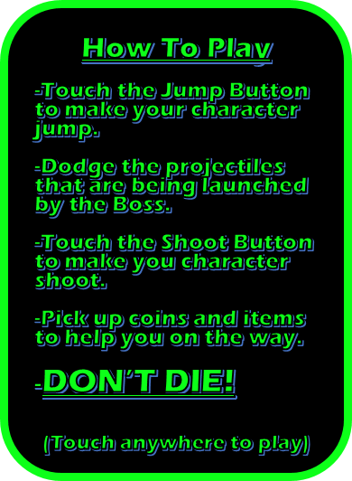

**Game Play**

After clicking the play button for the first time, the player will start the game being greeted with the instructions how to play and a boss shooting at the player. If the player wishes to dodge the fire balls being shot at them, the player can simply tap the jump button.

.

Along the way you will see two different items that you can pick up along the way:

 Ammo which you can use to shoot the boss.

 Coin which when you enough they give you a shield obtain a shield.

You can always check to see how much ammo and coins that you have in game by looking in the top left portion of your screen.

When you want to fire back at the boss and have collected some ammo just click the shoot button in the bottom right



You can tell how much health the boss has by looking at the bottom of the screen at the boss’s health bar.



If you ever need to pause the game there is the pause button at the top right of the screen



Be sure to avoid the fire balls the boss shoots at you!

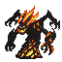

If you are to be hit by one of these fireballs it will result in a game over and you will lose all progress that you have made. Though when you have obtained enough coins your character will go blue and you will have a shield!

This will protect you for one hit.



After hit you will become vulnerable again.



**How to Win**

Winning in this game is very tough, what the player must do is defeat all the bosses without dying. Though winning isn’t the only goal. Each time the game is played how long they live is recorded, so if they player isn’t good enough to win they can rack up to see how much time they have stay alive for.

**Addendum**

Some of the things that we planned sadly did not get done and here is a memorial for all those things that were not implemented.

* Different Skins for the playable character
* Item power ups
  + Missiles
  + Reflector
  + Health packs
* Player health being more than 1 hit
* Multiple playable stages
* A scrolling background
* Playable for IOS

**Credits**

**Developers**

* **Jacob Carney**
* **Tanaka Mazivanhanga**
* **Matthew Chu**
* **Hao Zhou**

**Art**

* Opengameart.org

**Thank You to:**

* Brent Aurli
* LibGDX
* Mockito